Chapter 3: Problem 29
;**************************************************************************;
; Chapter 3: Problem 29 ;
; Create a 83.3 kHz square wave on P1.0 ;
;**************************************************************************;

CSEG AT 0 ;Create code segment at address 0

LJMP START ;Jump beginning of code

CSEG AT 100H ;Create code segment at address 100H

START: SETB P1.0 ;Set P1.0 high

MOV R1, #02H ;5 cycles
WAIT1: DJNZ R1, WAIT1 ;

CLR P1.0 ;Set P1.0 Low
NOP ;1 cycle
NOP ;1 cycle
NOP ;1 cycle
SJMP START ;Loop to beginning (2 cycles)
END

Problem 29 – Description
Write a program to create an 83.3 kHz square wave on P1.0. (Assume 12 MHz operation.)

This program requires that the P1.0 bit is set to a ‘1’ then held for a number of cycles. Next, the bit is cleared and held for a number of cycles. This loop is repeated to create a square wave. Since the frequency specified is 83.3 kHz, this means that period of oscillation is 12 us. Therefore, since the 8051 is running off of a 12 MHz clock, each cycle lasts 1 us.

The solution is to hold the bit high for 6 instruction cycles and low for 6 instruction cycles, then repeat this process. The program above accomplishes this task. The START label is the beginning of the loop. The SETB P1.0 instruction lasts one cycle, and the bit is set towards the end of the execution cycle. The MOV R1, #02H and DJNZ R1, WAIT1 instructions use 5 instruction cycles to execute and the CLR P1.0 takes up the 6th cycle. Therefore, the bit has been held high for six instruction cycles. The bit is now cleared and NOPs are used to wait three instruction cycles. The loop and setting P1.0 use three instruction cycles for a total of six. Therefore, the bit has been held low for six instruction cycles. The program repeats forever.

The program was tested using the debugger in Keil uVision 2. The number of states that the bit was held high and low was counted while stepping through the program.

Problem 29 – List Output
A51 MACRO ASSEMBLER CH3_P29 02/28/2001 13:56:36 PAGE 1

MACRO ASSEMBLER A51 V6.10
OBJECT MODULE PLACED IN .\ch3_p29.OBJ
ASSEMBLER INVOKED BY: C:\Program Files\Keil\C51\BIN\A51.EXE .\ch3_p29.a51 SET(SMALL) DEBUG EP

LOC OBJ LINE SOURCE

1 ;***********************************************************************;
2 ; Chapter 3: Problem 29 ;
3 ; Create a 83.3 kHz square wave on P1.0 ;
4 ;***********************************************************************;
5
---- 6 CSEG AT 0 ;Create code segment at address 0
7
0000 020100 8 LJMP START ;Jump beginning of code
9
---- 10 CSEG AT 100H ;Create code segment at address 100H
11
0100 D290 12 START: SETB P1.0 ;Set P1.0 high
13
0102 7902 14 MOV R1, #02H ;
0104 D9FE 15 WAIT1: DJNZ R1, WAIT1 ;
16
0106 C290 17 CLR P1.0 ;Set P1.0 Low
0108 00 18 NOP ;1 cycle
0109 00 19 NOP ;1 cycle
010A 00 20 NOP ;1 cycle
010B 80F3 21 SJMP START ;Loop to beginning (2 cycles)
22 END

A51 MACRO ASSEMBLER CH3_P29 02/28/2001 13:56:36 PAGE 2

SYMBOL TABLE LISTING
------ ----- -------

N A M E T Y P E V A L U E ATTRIBUTES

P1 . . . . . . . . D ADDR 0090H A
START. . . . . . . C ADDR 0100H A
WAIT1. . . . . . . C ADDR 0104H A

REGISTER BANK(S) USED: 0

ASSEMBLY COMPLETE. 0 WARNING(S), 0 ERROR(S)

Chapter 3: Problem 30
;**************************************************************************;
; Chapter 3: Problem 30 ;
; Create a 4 us active-high pulse on P1.7 every 200 us ;
;**************************************************************************;

CSEG AT 0 ;Create code segment at address 0

LJMP START ;Jump beginning of code

CSEG AT 100H ;Create code segment at address 100H

START: SETB P1.7 ;Set P1.7 high
NOP ;1 cycle
NOP ;1 cycle
NOP ;1 cycle

CLR P1.7 ;Clear P1.7

MOV R1, #60H ;Wait 193 cycles
WAIT2: DJNZ R1, WAIT2 ;

SJMP START ;Loop to beginning (2 cycles)

END

Problem 30 – Description

Write a program to generate a 4 us active-high pulse on P1.7 every 200 us.

This program requires that the P1.0 bit is set to a ‘1’ then held for a number of cycles. Next, the bit is cleared and held for a number of cycles. This loop is repeated to create an active high pulse. The problem statement gives that the 8051 is using a 12 MHz clock. Therefore, each instruction cycle lasts 1 us.

The solution is to hold the bit high for 4 instruction cycles and low for 196 instruction cycles, then repeat this process. The program above accomplishes this task. The START label is the beginning of the loop. The SETB P1.0 instruction lasts one cycle, and the bit is set towards the end of the execution cycle. The MOV R1, #02H and DJNZ R1, WAIT1 instructions use 5 clock cycles to execute and the CLR P1.0 instruction takes up the 6th instruction cycle. Therefore, the bit has been held high for four instruction cycles. The bit is now cleared. The MOV R1, #60H and DJNZ R1, WAIT2 instructions use 193 clock cycles to execute. The loop and setting P1.0 use three clock cycles for a total of 196. Therefore, the bit has been held low for 196 instruction cycles. The program repeats forever.

The program was tested using the debugger in Keil uVision 2. The number of states that the bit was held high and low was counted while stepping through the program.

Problem 30 – List Output
A51 MACRO ASSEMBLER CH3_P30 02/28/2001 14:11:42 PAGE 1

MACRO ASSEMBLER A51 V6.10
OBJECT MODULE PLACED IN .\ch3_p30.OBJ
ASSEMBLER INVOKED BY: C:\Program Files\Keil\C51\BIN\A51.EXE .\ch3_p30.a51 SET(SMALL) DEBUG EP

LOC OBJ LINE SOURCE

1 ;***********************************************************************;
2 ; Chapter 3: Problem 30 ;
3 ; Create a 4 us active-high pulse on P1.7 every 200 us ;
4 ;***********************************************************************;
5
---- 6 CSEG AT 0 ;Create code segment at address 0
7
0000 020100 8 LJMP START ;Jump beginning of code
9
---- 10 CSEG AT 100H ;Create code segment at address 100H
11
0100 D297 12 START: SETB P1.7 ;Set P1.7 high
0102 00 13 NOP ;1 cycle
0103 00 14 NOP ;1 cycle
0104 00 15 NOP ;1 cycle
16
0105 C297 17 CLR P1.7 ;Clear P1.7
18
0107 7960 19 MOV R1, #60H ;Wait 193 cycles
0109 D9FE 20 WAIT2: DJNZ R1, WAIT2 ;
21
010B 80F3 22 SJMP START ;Loop to beginning (2 cycles)
23
24 END

A51 MACRO ASSEMBLER CH3_P30 02/28/2001 14:11:42 PAGE 2

SYMBOL TABLE LISTING
------ ----- -------

N A M E T Y P E V A L U E ATTRIBUTES

P1 . . . . . . . . D ADDR 0090H A
START. . . . . . . C ADDR 0100H A
WAIT2. . . . . . . C ADDR 0109H A

REGISTER BANK(S) USED: 0

ASSEMBLY COMPLETE. 0 WARNING(S), 0 ERROR(S)

Chapter 3: Problem 31a
;********************************************************************;
; Chapter 3: Problem 31A ;
; Create 3 input NOR gate ;
;********************************************************************;

CSEG AT 0 ;Create code segment at address 0

LJMP START ;Jump beginning of code

CSEG AT 100H ;Create code segment at address 100H

START: MOV C, P1.4 ;Or bits 4, 5, 6 of P1
ORL C, P1.5
ORL C, P1.6
CPL C ;Complement the result
MOV P1.7, C ;Output the result to P1.7
SJMP START ;Loop to beginning
END

Problem 31a – Description
Write a program to implement the logic operation shown below.

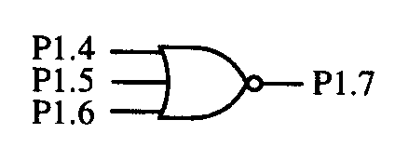

The solution to this problem is to OR the bits P1.4, P1.5, and P1.6 through the carry bit, then output the compliment of this result on P1.7.

The program was tested by manually stepping through the program using the debugger after changing the inputs to account for all eight possible combinations of inputs and verifying the output was indeed a NOR3.

The worst case propagation delay would be if the P1.4 bit changed just after the bit was read. Then the program would cycle through to the end taking 6 cycles and then cycle through to the output again taking 5 cycles. Therefore, the worst-case propagation delay would be 11 us.

Problem 31a – List Output
A51 MACRO ASSEMBLER CH3_P31A 02/27/2001 22:02:06 PAGE 1

MACRO ASSEMBLER A51 V6.10
OBJECT MODULE PLACED IN .\ch3_p31a.OBJ
ASSEMBLER INVOKED BY: C:\Program Files\Keil\C51\BIN\A51.EXE .\ch3_p31a.a51 SET(SMALL) DEBUG EP

LOC OBJ LINE SOURCE

1 ;********************************************************************;
2 ; Chapter 3: Problem 31A ;
3 ; Create 3 input NOR gate ;
4 ;%%%%%%%%%%%%%%%%%%%%%%%%%%%%%%%%%%%%%%%%%%%%%%%%%%%%%%%%%%%%%%%%%%%%;
5
---- 6 CSEG AT 0 ;Create code segment at address 0
7
0000 020100 8 LJMP START ;Jump beginning of code
9
---- 10 CSEG AT 100H ;Create code segment at address 100H
11
0100 A294 12 START: MOV C, P1.4 ;Or bits 4, 5, 6 of P1
0102 7295 13 ORL C, P1.5
0104 7296 14 ORL C, P1.6
0106 B3 15 CPL C ;Complement the result
0107 9297 16 MOV P1.7, C ;Output the result to P1.7
0109 80F5 17 SJMP START ;Loop to beginning
18 END

A51 MACRO ASSEMBLER CH3_P31A 02/27/2001 22:02:06 PAGE 2

SYMBOL TABLE LISTING
------ ----- -------

N A M E T Y P E V A L U E ATTRIBUTES

P1 . . . . . . . . D ADDR 0090H A
START. . . . . . . C ADDR 0100H A

REGISTER BANK(S) USED: 0

ASSEMBLY COMPLETE. 0 WARNING(S), 0 ERROR(S)

Chapter 3: Problem 31b

;********************************************************************;
; Chapter 3: Problem 31b ;
; Create 8 input NAND gate ;
;********************************************************************;

CSEG AT 0 ;Create code segment at address 0

LJMP START ;Jump beginning of code

CSEG AT 100H ;Create code segment at address 100H

START: MOV R0,P1 ;Move data on P1 to R0

CJNE R0, #0FFH, NOT_EQ ;If there are any 0's, then the nand
CLR P2.7 ;output will be a 1, otherwise if all
SJMP START ;1's, output is 0

NOT_EQ: SETB P2.7 ;Set output to 1 since there was at
SJMP START ;least one 0
END

Problem 31b – Description
Write a program to implement the logic operation shown below.
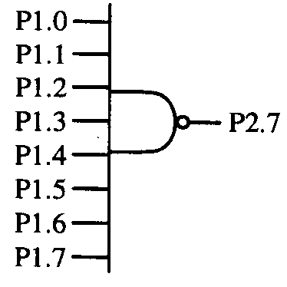

The NAND8 gate can be thought of as an if statement. If any of the input bits are ‘0’ then, the AND result will be ‘0’ and the NAND result will be a ‘1’. The only case where the output will be ‘0’ is when the input is all ‘1’s.

The program above realizes this statement. The data on P1 is moved to the accumulator. The next statement compares the accumulator to the case where all input bits are ‘1’ (0FFH). If the accumulator is not equal to 0FFH, then the program jumps to the NOT_EQ label and outputs a ‘1’ on P2.7. In the case where the accumulator is equal to 0FFH, the program outputs a ‘0’ on P2.7.

The program was tested by manually stepping through the program using the debugger in Keil uVision 2 after changing the inputs to account for all 256 possible combinations of inputs and verifying the output was indeed a NAND8.

The worst-case propagation delay would occur if a input changed just after the port was read. Then the program would have to cycle through taking 5 cycles. The program would now have the new input and cycle through until the new data is output taking 4 cycles. Therefore, the worst-case propagation delay would be 9 us.

Problem 31b – List Output

A51 MACRO ASSEMBLER CH3_P31B 02/27/2001 22:05:39 PAGE 1

MACRO ASSEMBLER A51 V6.10
OBJECT MODULE PLACED IN .\ch3_p31b.OBJ
ASSEMBLER INVOKED BY: C:\Program Files\Keil\C51\BIN\A51.EXE .\ch3_p31b.a51 SET(SMALL) DEBUG EP

LOC OBJ LINE SOURCE

1 ;********************************************************************;
2 ; Chapter 3: Problem 31b ;
3 ; Create 8 input NAND gate ;
4 ;%%%%%%%%%%%%%%%%%%%%%%%%%%%%%%%%%%%%%%%%%%%%%%%%%%%%%%%%%%%%%%%%%%%%;
5
---- 6 CSEG AT 0 ;Create code segment at address 0
7
0000 020100 8 LJMP START ;Jump beginning of code
9
---- 10 CSEG AT 100H ;Create code segment at address 100H
11
0100 A890 12 START: MOV R0,P1 ;Move data on P1 to R0
13
0102 B8FF04 14 CJNE R0, #0FFH, NOT_EQ ;If there are any 0's, then the nand
0105 C2A7 15 CLR P2.7 ;output will be a 1, otherwise if all
0107 80F7 16 SJMP START ;1's, output is 0
17
0109 D2A7 18 NOT_EQ: SETB P2.7 ;Set output to 1 since there was at
010B 80F3 19 SJMP START ;least one 0
20 END

A51 MACRO ASSEMBLER CH3_P31B 02/27/2001 22:05:39 PAGE 2

SYMBOL TABLE LISTING
------ ----- -------

N A M E T Y P E V A L U E ATTRIBUTES

NOT_EQ . . . . . . C ADDR 0109H A
P1 . . . . . . . . D ADDR 0090H A
P2 . . . . . . . . D ADDR 00A0H A
START. . . . . . . C ADDR 0100H A

REGISTER BANK(S) USED: 0

ASSEMBLY COMPLETE. 0 WARNING(S), 0 ERROR(S)

Chapter 3: Problem 31c

;********************************************************************;
; Chapter 3: Problem 31c ;
; Create logic circuit in Problem 31.c, pg 78 ISM ;
;********************************************************************;

CSEG AT 0 ;Create code segment at address 0

LJMP START ;Jump beginning of code

CSEG AT 100H ;Create code segment at address 100H

START: MOV C, P1.4 ;Move P1.4 to carry bit
ORL C, /P1.5 ;Or carry with /P1.5
ORL C, P1.6 ;Or carry with P1.6
MOV P1.7, C ;Output result on P1.7
SJMP START ;Repeat forever
END

Problem 31c – Description
Write a program to implement the logic operation shown below.
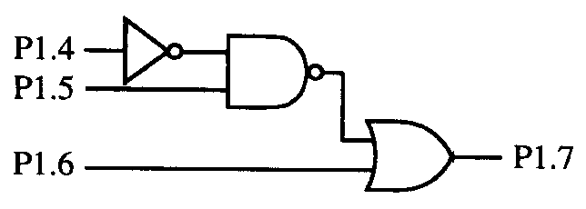

The equation for the logic circuit is given by 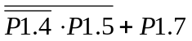which has an equivalent equation of 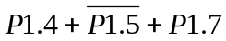. The program above realizes this logic equation. The bit P1.4 is moved to the carry bit, the complement of P1.5 is ORed with the carry bit and P1.6 is also ORed with the carry bit. The output data from the carry bit is moved to P1.7.

A truth table was created for this logic circuit. Each of eight combinations was manually tested in the debugger in Keil uVision 2 to make sure the output was as expected.

The worst-case propagation delay would be if the P1.4 bit changed just after the bit was read. Then the program would cycle through to the end taking 5 cycles and then cycle through to the output again taking 4 cycles. Therefore, the worst-case propagation delay would be 9 us.

Problem 31c – List Output

A51 MACRO ASSEMBLER CH3_P31C 02/27/2001 22:08:02 PAGE 1

MACRO ASSEMBLER A51 V6.10
OBJECT MODULE PLACED IN .\ch3_p31c.OBJ
ASSEMBLER INVOKED BY: C:\Program Files\Keil\C51\BIN\A51.EXE .\ch3_p31c.a51 SET(SMALL) DEBUG EP

LOC OBJ LINE SOURCE

1 ;********************************************************************;
2 ; Chapter 3: Problem 31c ;
3 ; Create logic circuit in Problem 31.c, pg 78 ISM ;
4 ;%%%%%%%%%%%%%%%%%%%%%%%%%%%%%%%%%%%%%%%%%%%%%%%%%%%%%%%%%%%%%%%%%%%%;
5
---- 6 CSEG AT 0 ;Create code segment at address 0
7
0000 020100 8 LJMP START ;Jump beginning of code
9
---- 10 CSEG AT 100H ;Create code segment at address 100H
11
0100 A294 12 START: MOV C, P1.4 ;Move P1.4 to carry bit
0102 A095 13 ORL C, /P1.5 ;Or carry with /P1.5
0104 7296 14 ORL C, P1.6 ;Or carry with P1.6
0106 9297 15 MOV P1.7, C ;Output result on P1.7
0108 80F6 16 SJMP START ;Repeat forever
17 END

A51 MACRO ASSEMBLER CH3_P31C 02/27/2001 22:08:02 PAGE 2

SYMBOL TABLE LISTING
------ ----- -------

N A M E T Y P E V A L U E ATTRIBUTES

P1 . . . . . . . . D ADDR 0090H A
START. . . . . . . C ADDR 0100H A

REGISTER BANK(S) USED: 0

ASSEMBLY COMPLETE. 0 WARNING(S), 0 ERROR(S)

Chapter 3: Problem 39

;**************************************************************************;
; Chapter 3: Problem 39 ;
; Create 7 segment decoder ;
;**************************************************************************;

CSEG AT 0

LJMP START

TABLE: db 3FH, 06H, 5BH, 4FH, 66H, 6DH, 7DH, 07H, 7FH, 67H, 77H, 7CH, 39H, 5EH, 79H, 71H

CSEG AT 100H

START: MOV P3, #0FH ;Allow bits 0 - 3 to be inputs

LOOP: MOV A, P3 ;Read P3

ANL A, #0FH ;Mask input bits
MOV DPTR, #TABLE ;Get table address
MOVC A,@A+DPTR ;Get ith entry in table

MOV P1, A ;Output to P1
SJMP LOOP ;Repeat forever

END

Problem 39 – Description
A 4-bit DIP switch and a common-anode 7-segment LED are connected to an 8051 as shown below. Write a program that continually reads a 4-bit code from the DIP switch and updates the LEDs to display the appropriate hexadecimal character. For example, if the code 1100B is read, the hexadecimal character “C” should appear; thus, segments a through g respectively should be ON, OFF, OFF, ON, ON, ON, and OFF. Note that setting an 8051 port pin to “1” turns the corresponding segment “ON.”
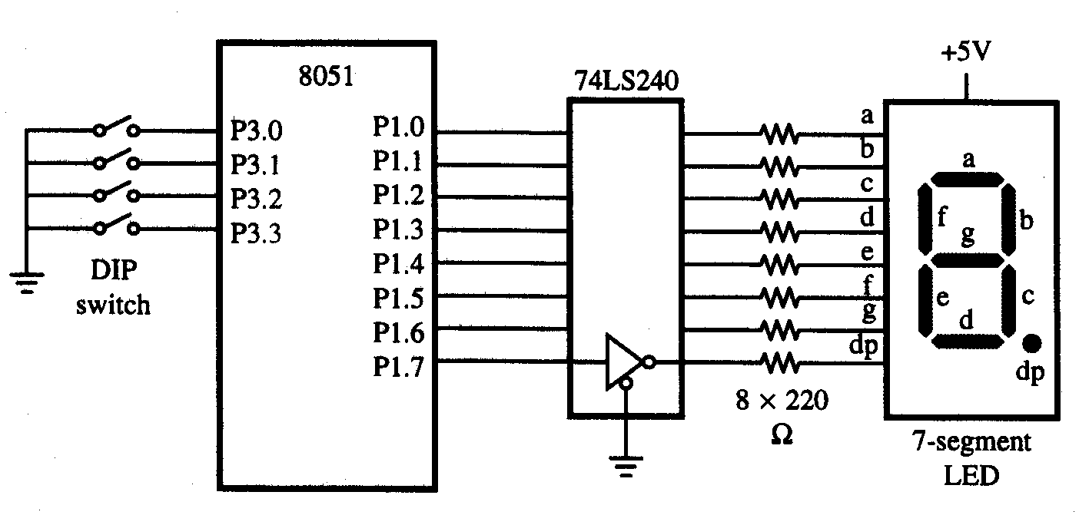

The truth table for the seven-segment display is located on the next page. This truth table was used to create a lookup table for each of the 16 possible inputs. In each case, the decimal point was left off. The hexadecimal codes for the segment output are stored in the program in the beginning of code space.

Seven Segment Display Truth Table
Hex | P3.3 | P3.2 | P3.1 | P3.0 | dp | g | f | e | d | c | b | a
0 | 0 | 0 | 0 | 0 | 0 | 0 | 1 | 1 | 1 | 1 | 1 | 1
1 | 0 | 0 | 0 | 1 | 0 | 0 | 0 | 0 | 0 | 1 | 1 | 0
2 | 0 | 0 | 1 | 0 | 0 | 1 | 0 | 1 | 1 | 0 | 1 | 1
3 | 0 | 0 | 1 | 1 | 0 | 1 | 0 | 0 | 1 | 1 | 1 | 1
4 | 0 | 1 | 0 | 0 | 0 | 1 | 1 | 0 | 0 | 1 | 1 | 0
5 | 0 | 1 | 0 | 1 | 0 | 1 | 1 | 0 | 1 | 1 | 0 | 1
6 | 0 | 1 | 1 | 0 | 0 | 1 | 1 | 1 | 1 | 1 | 0 | 1
7 | 0 | 1 | 1 | 1 | 0 | 0 | 0 | 0 | 0 | 1 | 1 | 1
8 | 1 | 0 | 0 | 0 | 0 | 1 | 1 | 1 | 1 | 1 | 1 | 1
9 | 1 | 0 | 0 | 1 | 0 | 1 | 1 | 0 | 0 | 1 | 1 | 1
A | 1 | 0 | 1 | 0 | 0 | 1 | 1 | 1 | 0 | 1 | 1 | 1
b | 1 | 0 | 1 | 1 | 0 | 1 | 1 | 1 | 1 | 1 | 0 | 0
C | 1 | 1 | 0 | 0 | 0 | 0 | 1 | 1 | 1 | 0 | 0 | 1
d | 1 | 1 | 0 | 1 | 0 | 1 | 0 | 1 | 1 | 1 | 1 | 0
E | 1 | 1 | 1 | 0 | 0 | 1 | 1 | 1 | 1 | 0 | 0 | 1
F | 1 | 1 | 1 | 1 | 0 | 1 | 1 | 1 | 0 | 0 | 0 | 1

Since bits 3 down to 0 on Port 3 are used as input bits, Port 3 must be initialized as an input port. Therefore, a ‘1’ was written to each of these pins first. Next, the data from the port was stored into the accumulator. The address of the table was next stored into the data pointer. Now it is possible to obtain the required output from the lookup table by obtaining the ith entry from the table at address @A + DPTR. This output was moved to P1 and the process was repeated forever.

The program was tested by manually stepping through the program using the debugger in Keil uVision 2 after changing the inputs to account for all 16 possible combinations of inputs and verifying the output was indeed as required in the truth table.

Problem 39 – List Output

A51 MACRO ASSEMBLER CH3_P39B 02/28/2001 10:05:42 PAGE 1

MACRO ASSEMBLER A51 V6.10
OBJECT MODULE PLACED IN .\ch3_p39b.OBJ
ASSEMBLER INVOKED BY: C:\Program Files\Keil\C51\BIN\A51.EXE .\ch3_p39b.a51 SET(SMALL) DEBUG EP

LOC OBJ LINE SOURCE

1 ;***********************************************************************;
2 ; Chapter 3: Problem 39 ;
3 ; Create 7 segment decoder ;
4 ;***********************************************************************;
5
---- 6 CSEG AT 0
7
0000 020100 8 LJMP START
9
0003 3F065B4F 10 TABLE: db 3FH, 06H, 5BH, 4FH, 66H, 6DH, 7DH, 07H, 7FH, 67H, 77H, 7CH, 39H, 5EH, 79H, 71H
0007 666D7D07
000B 7F67777C
000F 395E7971
11
---- 12 CSEG AT 100H
13
0100 75B00F 14 START: MOV P3, #0FH ;Allow bits 0 - 3 to be inputs
15
0103 E5B0 16 LOOP: MOV A, P3 ;Read P3
17
0105 540F 18 ANL A, #0FH ;Mask input bits
0107 900003 19 MOV DPTR, #TABLE ;Get table address
010A 93 20 MOVC A,@A+DPTR ;Get ith entry in table
21
010B F590 22 MOV P1, A ;Output to P1
010D 80F4 23 SJMP LOOP ;Repeat forever
24
25 END

A51 MACRO ASSEMBLER CH3_P39B 02/28/2001 10:05:42 PAGE 2

SYMBOL TABLE LISTING
------ ----- -------

N A M E T Y P E V A L U E ATTRIBUTES

LOOP . . . . . . . C ADDR 0103H A
P1 . . . . . . . . D ADDR 0090H A
P3 . . . . . . . . D ADDR 00B0H A
START. . . . . . . C ADDR 0100H A
TABLE. . . . . . . C ADDR 0003H A

REGISTER BANK(S) USED: 0

ASSEMBLY COMPLETE. 0 WARNING(S), 0 ERROR(S)

